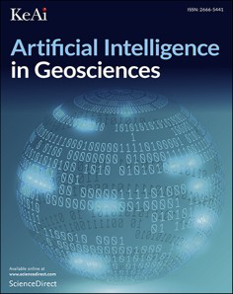

[Artificial Intelligence in G](https://doi.org/10.1016/j.aiig.2022.10.003)e[osciences 3 (2022) 86–100](https://doi.org/10.1016/j.aiig.2022.10.003)

Contents lists available at ScienceDirect

Artificial Intelligence in Geosciences

journal homepage: [www.keaipublishing.com/en/journals/artificial-intelligence-in-geoscience](https://www.keaipublishing.com/en/journals/artificial-intelligence-in-geosciences)s

Advanced geochemical exploration knowledge using machine learning: Prediction of unknown elemental concentrations and operational prioritization of Re-analysis campaigns

Steven E. Zhanga,b, Julie E. Bourdeaua,b, Glen T. Nwailab,*, Yousef Ghorbanic

a *Geological Survey of Canada, 601 Booth Street, Ottawa, Ontario, K1A 0E8, Canada*   
b *Wits Mining Institute, University of the Witwatersrand, 1 Jan Smuts Ave., Johannesburg, 2000, South Africa*   
c *Department of Civil, Environmental and Natural Resources Engineering, Luleå University of Technology, SE*–*971 87, Luleå, Sweden*

|  |  |
| --- | --- |
| A R T I C L E I N F O | A B S T R A C T |
| *Keywords:*  Machine learning  Re-purposing legacy data  Advanced exploration knowledge Canada  Geochemical data | In exploration geochemistry, advances in the detection limit, breadth of elements analyze-able, accuracy and precision of analytical instruments have motivated the re-analysis of legacy samples to improve confidence in geochemical data and gain more insights into potentially mineralized areas. While a re-analysis campaign in a geochemical exploration program modernizes legacy geochemical data by providing more trustworthy and higher-dimensional geochemical data, especially where modern data is considerably different than legacy data, it is an expensive exercise. The risk associated with modernizing such legacy data lies within its uncertainty in return (e.g., the possibility of new discoveries, in primarily greenfield settings). Without any advanced knowl-edge of yet unanalyzed elements, the importance of re-analyses remains ambiguous. To address this uncertainty, we apply machine learning to multivariate geochemical data from different regions in Canada (i.e., the Churchill Province and the Trans-Hudson Orogen) in order to use legacy geochemical data to predict modern and higher dimensional multi-elemental concentrations ahead of planned re-analyses. Our study demonstrates that legacy and modern geochemical data can be repurposed to predict yet unanalyzed elements that will be realized from re-analyses and in a manner that significantly reduces the latency to downstream usage of modern geochemical data (e.g., prospectivity mapping). Findings from this study serve as a pillar of a framework for exploration geologists to predictively explore and prioritize potentially mineralized districts for further prospects in a timely manner before employing more invasive and expensive techniques. |

**1. Introduction**

Geochemical exploration necessitates the methodical collection, processing and analysis of collected samples. In large exploration pro-grams (regional or national, decadal programs), this process takes time on the order of years to decades to map significant portions of target areas. Coincidentally, the evolution of analytical instruments has been roughly decadal from research to development, to deployment en masse (Balaram, 2021). This overlapping of timescales of advances in analyt-ical instrumentation and the operationalization of large exploration programs unfortunately means that, in a cyclical fashion, geochemical data becomes outdated and resampling and/or re-analyses are required. Outdated geochemical data is data that is analytically no longer the state-of-the-art (e.g., less analyzed elements than modern data). We

* Corresponding author.

*E-mail address:* [glen.nwaila@wits.ac.za](mailto:glen.nwaila@wits.ac.za) (G.T. Nwaila).

hereon refer to outdated geochemical data as ‘legacy’ geochemical data, although aside from specific changes in the analytical methodology, such data is identical to current geochemical data in terms of the requirement of manual labour during data generation. Within the data generation portion of geochemical exploration, the methodology expe-rienced drastic changes mainly in the analytical aspects relative to the sampling and processing methods, as analytical instruments have improved substantially in accuracy and precision, detection limits and the breadth of analyzable elements (Cohen et al., 2010; Balaram, 2021). At the moment, there is still further on-going research to adopt new techniques, such as Raman spectroscopy; and a move towards instru-ment miniaturization (Balaram, 2021). The cyclical modernization of geochemical exploration data is necessary in some cases, for example, to add additional elements that was absent in legacy data. However,

<https://doi.org/10.1016/j.aiig.2022.10.003>   
[Received 19 May 2022; Received in revised](https://doi.org/10.1016/j.aiig.2022.10.003) form 30 October 2022; Accepted 31 October 2022   
Available online 5 November 2022   
2666-5441/© 2022 [The Authors. Publishing services by Elsevier B.V.](http://creativecommons.org/licenses/by-nc-nd/4.0/) on behalf of KeAi Communications Co. Ltd. This is an open access article under the CC BY-NC-ND license (<http://creativecommons.org/licenses/by-nc-nd/4.0/>).

*S.E. Zhang et al.*  *Artificial Intelligence in Geosciences 3 (2022) 86–100*

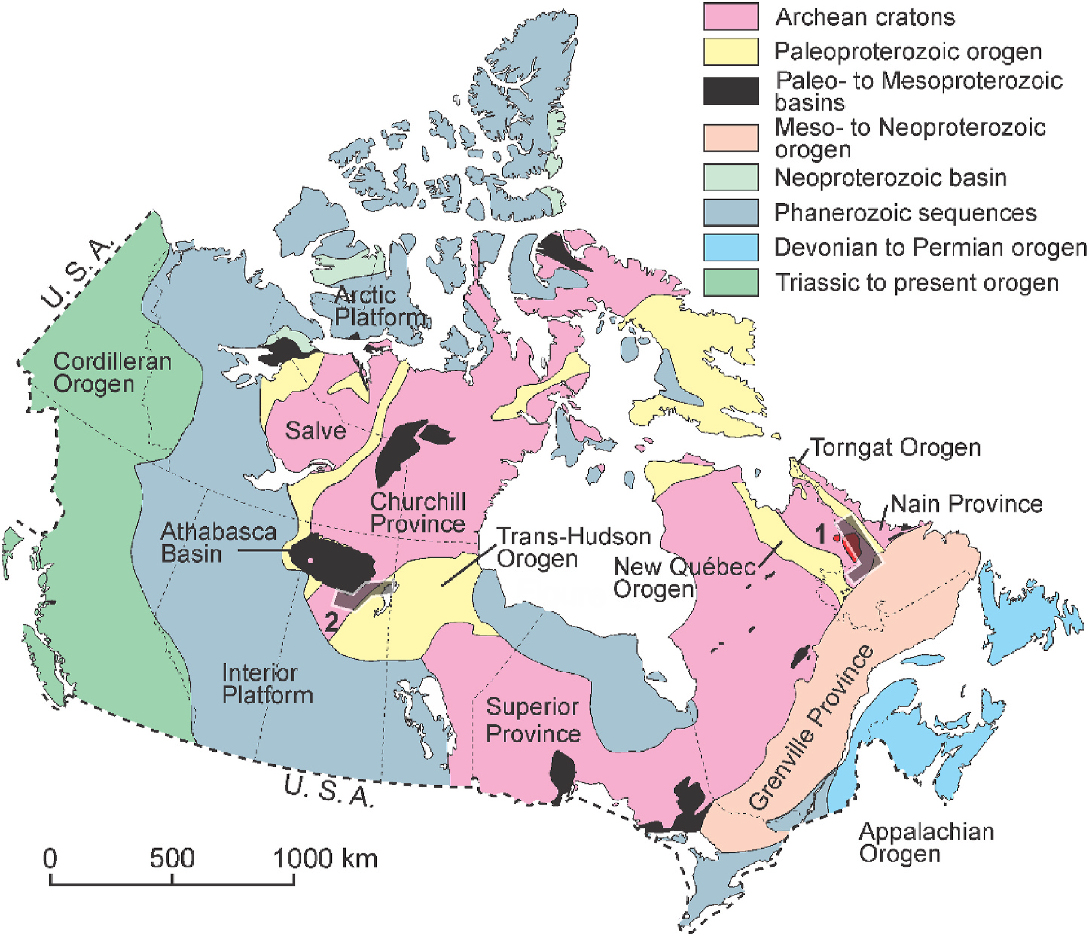

**Fig. 1.** Simplified geological map of Canada with the location of the lake sediment datasets used in this study. The dataset corresponding to the southeastern Churchill Province (shaded area labelled 1) is located in Labrador. Included in the southeastern Churchill Province is the location of the Mistatin Batholith (in red).

The dataset corresponding to the southwestern Churchill Province and Trans-Hudson Orogen (shaded area labelled 2) is located in Saskatchewan.

accomplishing this task using solely manual re-sampling and/or re-analysis is costly and maybe untimely for some elements. However, predictive data generation could be used to guide modernization of geochemical exploration data, and for some uses, even substitute for actual primary data.

Large regional and national geochemical survey programs are a key source of geochemical data. For example, the Geo-mapping for Energy and Minerals (GEM) program (Lebel, 2020; Geological Survey of Can-ada, 2022) is a Canadian national survey program that was initially conceived in 2008 to provide modern, publicly available geoscience knowledge of northern Canada to support increased exploration for re-sources (now known as the GEM-GeoNorth program [2020–2027]). Similar programs exist worldwide. For example, the Council for Geo-science in South Africa conducted a series of geochemical surveys that lasted into the early 2000s and are now expanding the survey using modern methods that better cover trace elements and particularly energy-transition and battery metals (Council for Geosciences, 2022). Viewing the GEM program as a prototype, the downstream purpose of the data resulting from these programs seems to be: construction of digital maps; provision of information that may be relevant to assess mineralization potential; and provision of information necessary to make informed decisions on general land use (GEM-GeoNorth, 2022). Depending on the natural landscape of the region being surveyed and the capability of the surveyor, many types of sample media could be available, such as: bulk rock, lake sediment, glacial till and water. Each type of media has its strengths and weaknesses, collection and pro-cessing methodology. A primary decision criterion in choosing sample media is its abundance and accessibility within a target area. For every type of sample media, in general, the resulting data (including legacy data) is produced by applying a highly rigorous and standardized methodology from collection to instrumental analysis. This greatly aids data usage, including data fusion.

87

*S.E. Zhang et al.*  *Artificial Intelligence in Geosciences 3 (2022) 86–100*

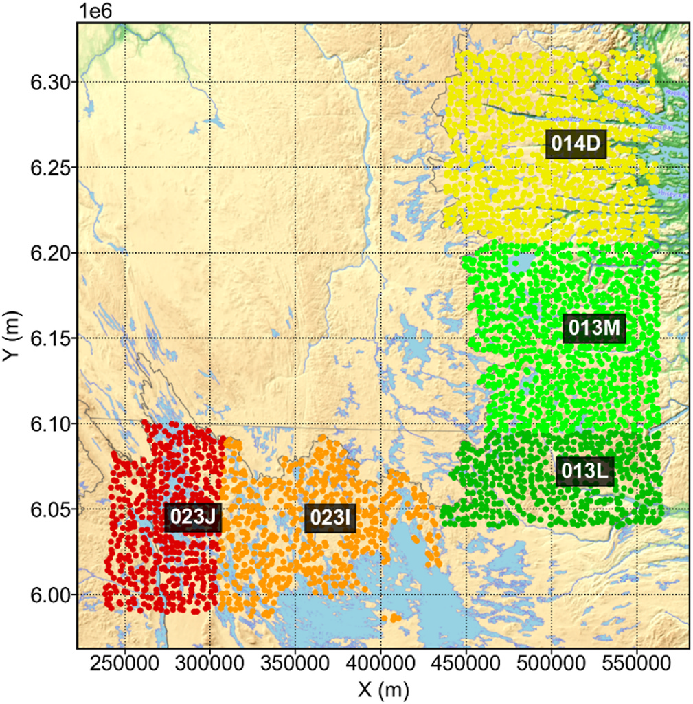

**Fig. 2.** Sample locations from the southeastern Churchill Province dataset, located in Labrador.

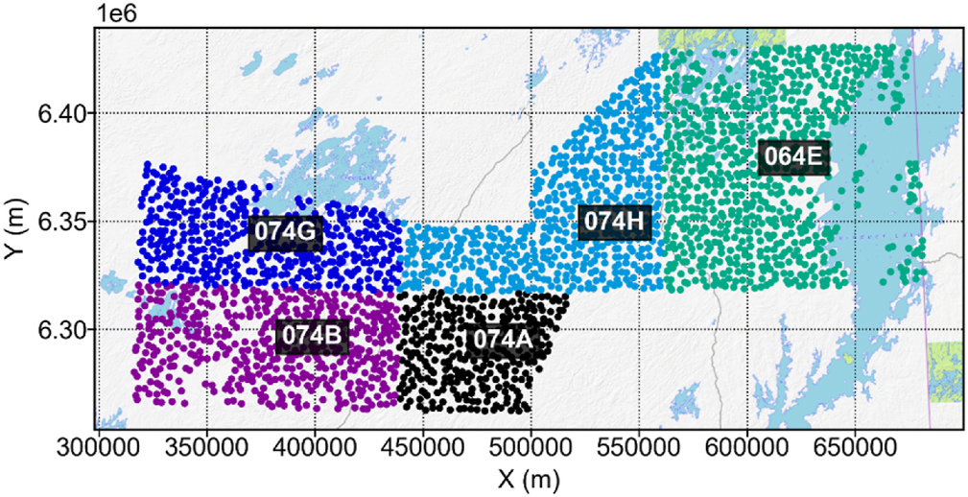

**Fig. 3.** Sample locations from the southwestern Churchill Province and Trans- Hudson Orogen dataset, located in northeastern Saskatchewan.

As part of a re-analysis campaign in the 1990s, the southeastern Churchill Province in Labrador area was also re-analyzed. In this fashion, the GEM program intends to re-analyze its collection of lake sediment samples to modernize its surficial geochemical data. However, GEM does not currently make use of predictive prioritization in its program execution in any capacity and targets that may be of interest to a modern economy (e.g., mineral deposits containing critical raw ma-terials) are best prioritized on a partial basis of a-priori knowledge of the geology of target areas (knowledge-driven). To the best of our knowl-edge, there is no geochemical exploration program that is currently performing predictive data generation.

Aside from differences in scientific data quality, a primary structural difference between the legacy and modern geochemical datasets (of sediments or otherwise) lies in the former’s lack of a breadth of ele-ments. For example, between 1970 and 1980s, lake sediment geochemical analysis at the Geological Survey of Canada data routinely contained up to 14 elements and did not include any of the rare earth elements. Similarly, for geochemical data that was generated by the Council for Geoscience in the 2000s, a common configuration is 23 el-ements (e.g., van Rooyen et al., 2004). This makes it impossible to leverage such legacy geochemical data to understand the national dis-tribution of unanalyzed trace elements, many of which have become

88

|  |  |  |  |  |  |  |  |  |
| --- | --- | --- | --- | --- | --- | --- | --- | --- |
| *S.E. Zhang et al.* | | *Artificial Intelligence in Geosciences 3 (2022) 86–100* | | | | | | |
| **Table 2**  Comparison of precision between older (1984–1986) and newer (2021) geochemical data for the southwestern Churchill Province and Trans-Hudson Orogen, located in northeastern Saskatchewan. LDL = lower detection limit, and RSD = relative standard deviation. All elemental means, unless otherwise stated, are given in ppm. The method to calculate precision is detailed in McCurdy and Garrett (2016). | | | | | | | | |
| Element | 1984–1986 data via AAS | 2020–2021 data via ICP-MS | | | | | | |
| Elemental mean | | Percentage censored LDL | | RSD (%) | | Elemental mean | Percentage censored LDL | RSD (%) |
| *Ag*  *As*  *Au*  *Cd*  *Co*  *Cu*  *Fe (%) Hg*  *Mn*  *Mo*  *Ni*  *Pb*  *Sb*  *U*  *V*  *Zn* | 0.24  8.39 | 95.42  58.17  100  43.79  2.61  0  0  0  0  55.56  0  90.2  94.12  1.31  2.61  0 | 49.22  4.08 | | 0.01  4.71  0.00  0.51  8.13  14.06  5.17  0.01  480.56  3.24  17.36  3.31  0.08  7.74  37.45  101.53 | | 0  21.97  37.88  0  0  0  0  0  1.52  0  0  0  8.33  0  0  0 | 13.62  14.15  67.67  6.38  3.56  3.62  4.29  14.11  6.89  4.40  4.55  7.66  41.33  4.27  4.45  5.14 |
| 0.37  7.28  14.31  5.15  0.01  911.42  4.09  13.52  7.53  0.25  8.24  38.24  100.73 | 26.42  11.65  8.00  7.48  11.05  21.22  21.39  6.10  6.85  9.43  8.65  9.96  7.72 | |

**Table 3**   
Random forest parameter grid.

|  |  |
| --- | --- |
| PARAMETER | RANGE |
| MAXIMUM DEPTH  MAXIMUM FEATURES  MINIMUM SAMPLES PER SPLIT MINIMUM SAMPLES PER LEAF | 5, 7, 9, 11, unlimited  2, 3, 4, 5, 6, 7, 8, unlimited 3, 4, 5, 6, unlimited  1, 2, 3, 4, 5, 6 |

modelling using machine learning. In the past, various machine learning algorithms have been demonstrated to be able to predict elemental concentrations (Zhang et al., 2021a, 2022). In particular, for our pur-pose, machine learning algorithms can be used to model the relation-ships between elements for matching samples in old and new geochemical datasets. The models can then be deployed to infer prob-able concentrations of yet unanalyzed elements in other areas ahead of their actual re-analyses.

In this study, we examine the feasibility of predicting elemental concentrations in areas with legacy data ahead of their re-analysis using machine learning, legacy and modern geochemical datasets. We show that a range of elements can be predicted with a range of performance profiles (measured using metrics). In addition, the spatial concordance between the predicted and actual elemental concentrations are gener-ally substantially better than that in the variable domain and should be

sufficient, such that predicted elemental concentration maps provide advanced exploration knowledge that could be used for operational prioritization and other downstream uses. We expect that our approach would be generalizable to other environments and exploration cam-paigns, provided that legacy and modern data both exist and that they can be repurposed and fused to provide a training dataset.

**2. Data and analytics methods**

*2.1. Data source and description*

The GEM program internally plans sampling and re-analysis using spatial areas that are defined by the National Topographic System (NTS), which is a Natural Resources Canada standard ([https://www.](https://www.nrcan.gc.ca/earth-sciences/geography/topographic-information/maps/national-topographic-system-maps/9767) [nrcan.gc.ca/earth-sciences/geography/topographic-information/map](https://www.nrcan.gc.ca/earth-sciences/geography/topographic-information/maps/national-topographic-system-maps/9767) [s/national-topographic-system-maps/9767). The southeastern Church](https://www.nrcan.gc.ca/earth-sciences/geography/topographic-information/maps/national-topographic-system-maps/9767)ill [Province lake-sediment dataset contains](https://www.nrcan.gc.ca/earth-sciences/geography/topographic-information/maps/national-topographic-system-maps/9767) samples that are located in Labrador, encompassing parts of NTS 014D, 013M and L, 023I and J (Figs. 1 and 2). The southwestern Churchill Province and Trans-Hudson Orogen lake-sediment dataset are located in northeastern Saskatch-ewan, encompassing parts of NTS 064E, 074A, B, G and H (Figs. 1 and 3).

Data for a total of 6,558 samples are available across the two survey areas and was used for this proof-of-concept study, with a spatial

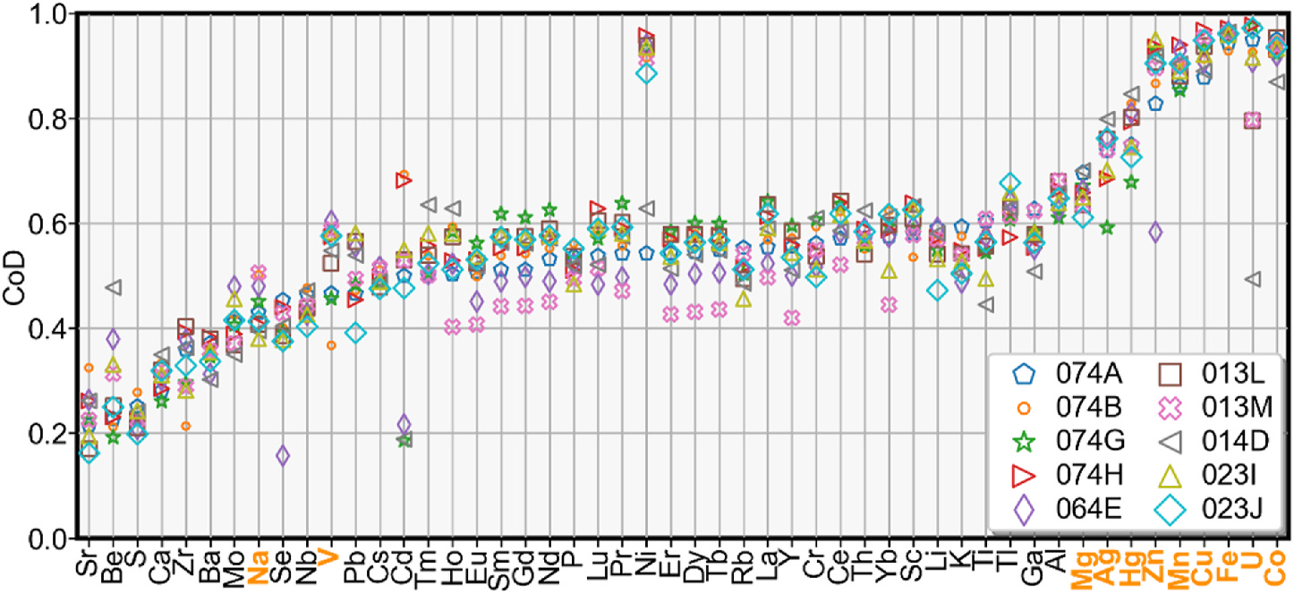

**Fig. 4.** Model selection performance summary – CoD (R2) score per element for each NTS zone for the best model. Elemental order is arranged by the averaged metric score from lowest to highest. Elements that are found in all of the older datasets are shown in bold orange text (includes Pb, Mo, Ag, Hg, Mn, Ni, Zn, Co, Cu, Fe and U).

89

*S.E. Zhang et al.*  *Artificial Intelligence in Geosciences 3 (2022) 86–100*

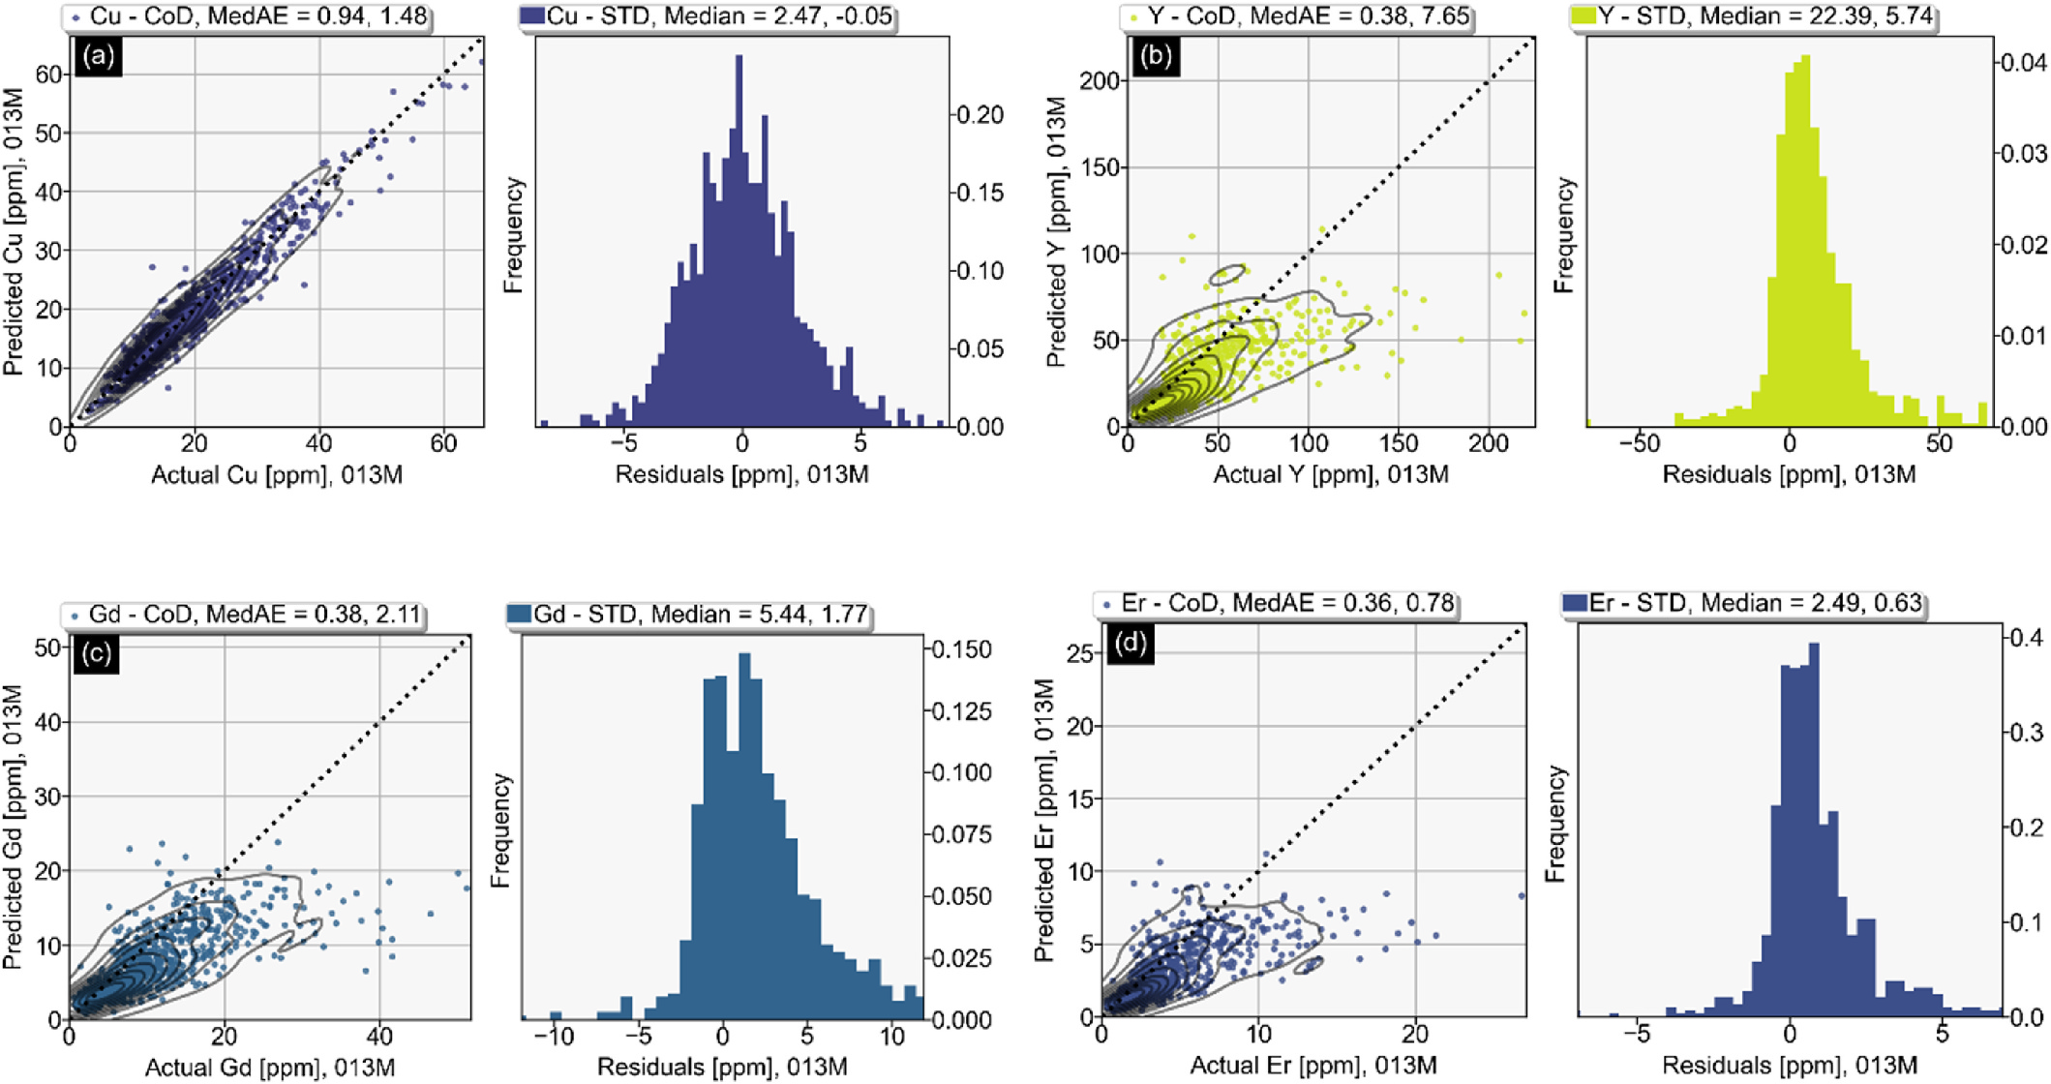

**Fig. 5.** Predicted versus actual for zone 013M for elements: Cu (a); Y (b); Gd (c); and Er (d). The CoD (R2) and MedAE metric scores are shown in the scatter plots.

The STD (standard deviation) and median values are shown in the histograms.

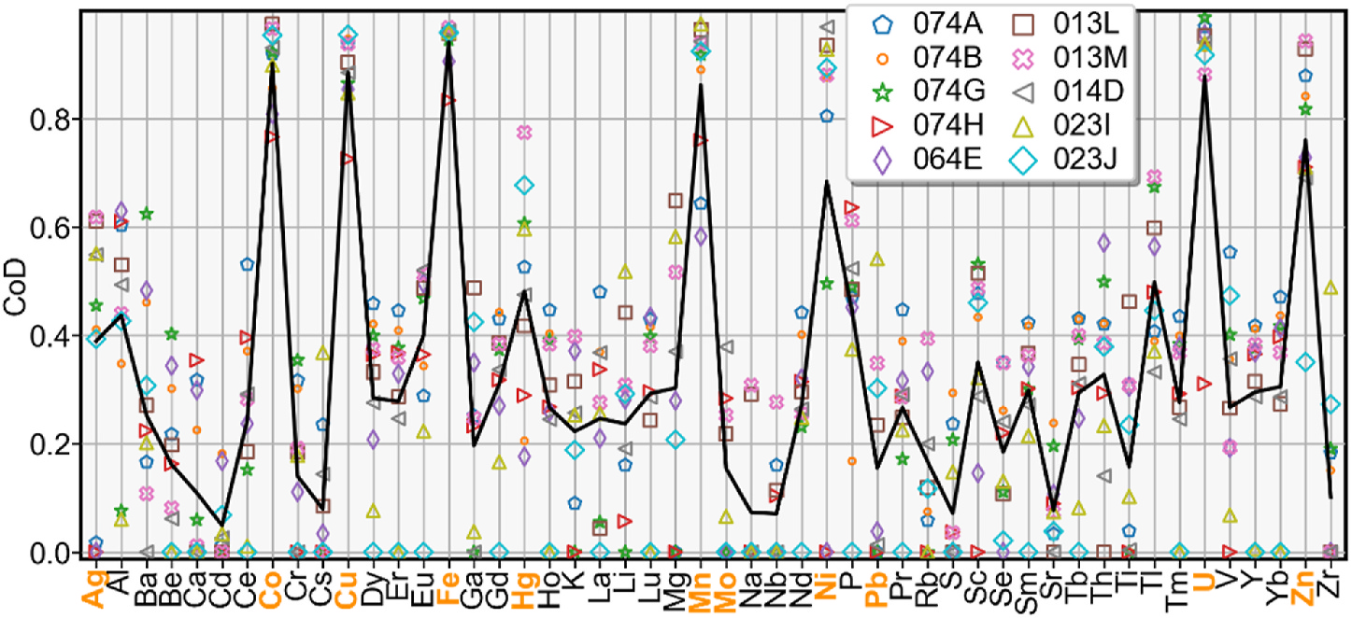

**Fig. 6.** Final testing performance summary – CoD (R2) scores for all predicted elements per zone. Elements that are found in all of the older datasets are shown in

bold orange text (includes Pb, Mo, Ag, Hg, Mn, Ni, Zn, Co, Cu, Fe and U).

resolution of roughly 1 sample per 13 km2 (Friske and Hornbrook, 1991). Legacy geochemical analyses were conducted for 14–34 ele-ments, whereas the modern analyses contain 65 elements (data de-scriptions are summarized in Table 1). Collected lake sediment samples for all analyses were air-dried, milled and sieved (−80 mesh). Geochemical analyses performed from 1978 to 1986 were conducted by Chemex Labs. Limited (now ALS Global) in Vancouver. All elements were determined via atomic absorption spectroscopy (AAS) with a smaller portion (up to 1,176 samples) also subjected to instrumental neutron activation analysis (INA). However, a vast majority of the an-alyses for all elements analyzed using INA were below the detection limit, such that the two least-affected elements – U and Fe, only con-tained 136 and 165 unique values. The loss on ignition (LOI) was determined via thermogravimetry, and U was determined via INA (delayed counting). Geochemical analyses performed in 1984 (OF 1643) were conducted by Barringer Magenta Ltd. In Ontario. Geochemical

90

*S.E. Zhang et al.*  *Artificial Intelligence in Geosciences 3 (2022) 86–100*

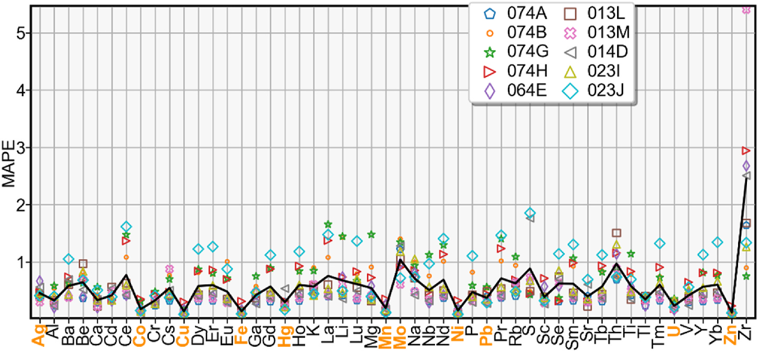

**Fig. 7.** Final testing performance summary – MAPE scores for all predicted elements per zone. Elements that are found in all of the older datasets are shown in bold

orange text (includes Pb, Mo, Ag, Hg, Mn, Ni, Zn, Co, Cu, Fe and U).

*2.2. Geological context*

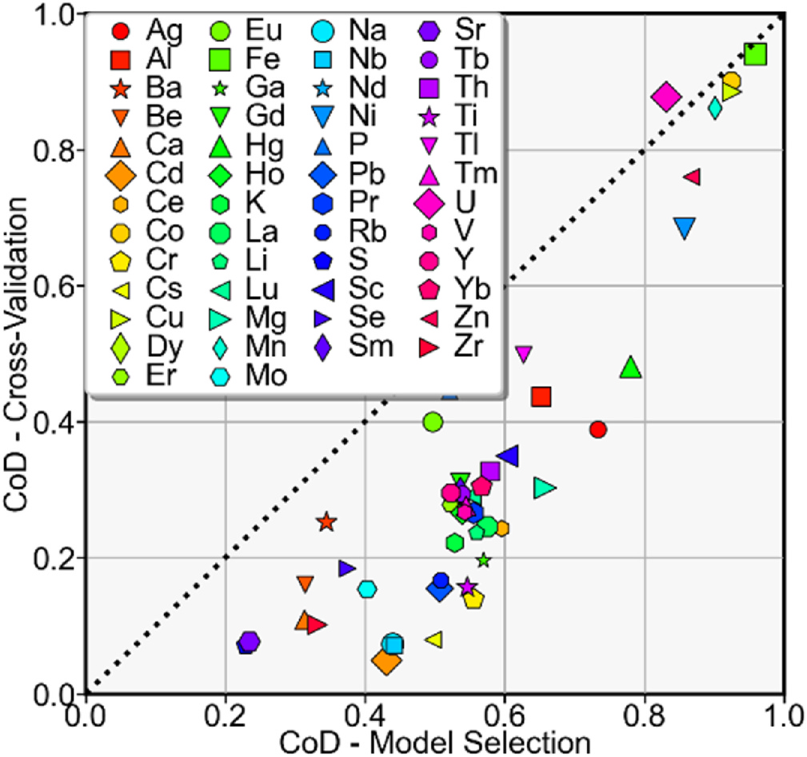

**Fig. 8.** Model selection versus cross-validation CoD (R2) scores for all predicted elements. The dotted line is the 1:1 line. Points plotting below the line indicate a loss in cross-validation performance relative to model selection and vice versa.

The data used in this study is intended to capture surficial geochemical variations of the sampled regions. Here, we provide a high- level description of the geological context to assist with the evaluation of predicted data aside from purely performance metrics. The southeastern Churchill Province is located in Labrador (Fig. 1) and has been inter-preted as an elongate sliver of Archean to early-Proterozoic continental crust that was accreted between the colliding Superior (west) and North Atlantic (east) cratons during the Paleoproterozoic (James et al., 1996; James and Dunning, 2000; Wardle et al., 2002; Corrigan et al., 2018). Lithologies consist primarily of para- and ortho-gneisses, migmatites and low-to medium-metamorphic grade supracrustal and plutonic rocks. Subsequently, Mesoproterozoic-aged intrusions of variable composition (anorthosite-gabbro-troctolite, granite and syenite) intruded in the area (Hammouche et al., 2012). Notably, the Mistastin Batholith (1.4 Ga), is locally highly enriched in Rare Earth Elements [REEs], Zr, Y ± Be, Nb, U and Th (Hammouche et al., 2012). One of these zones of enrichment is hosted by the Misery Lake peralkaline syenite (1409.7 ± 1.2 Ma; David et al., 2012; Hammouche et al., 2012) and most notably by the Strange Lake peralkaline complex (1240 ± 2 Ma), which has indicated mineral resources of 278 Mt at 0.93% total REE oxide (Miller, 1990; Gowans et al., 2014; Zajac, 2015; McClenaghan et al., 2017, 2019). Glacial erosion during the Wisconsin glaciation remobilized large volumes of REE-ri ch debris towards the northeast, forming a dispersal train that can be detected in excess of 50 km down the ice (McClenaghan et al., 2017, 2019 and references therein; Zhang et al., 2022). However, the legacy data prior to the 2016 re-analysis did not contain analyses of REEs.

The southwestern Churchill Province and Trans-Hudson Orogen is located in northeastern Saskatchewan (Fig. 1). The southwestern Churchill Province is characterized by Archean gneisses, granitoids and

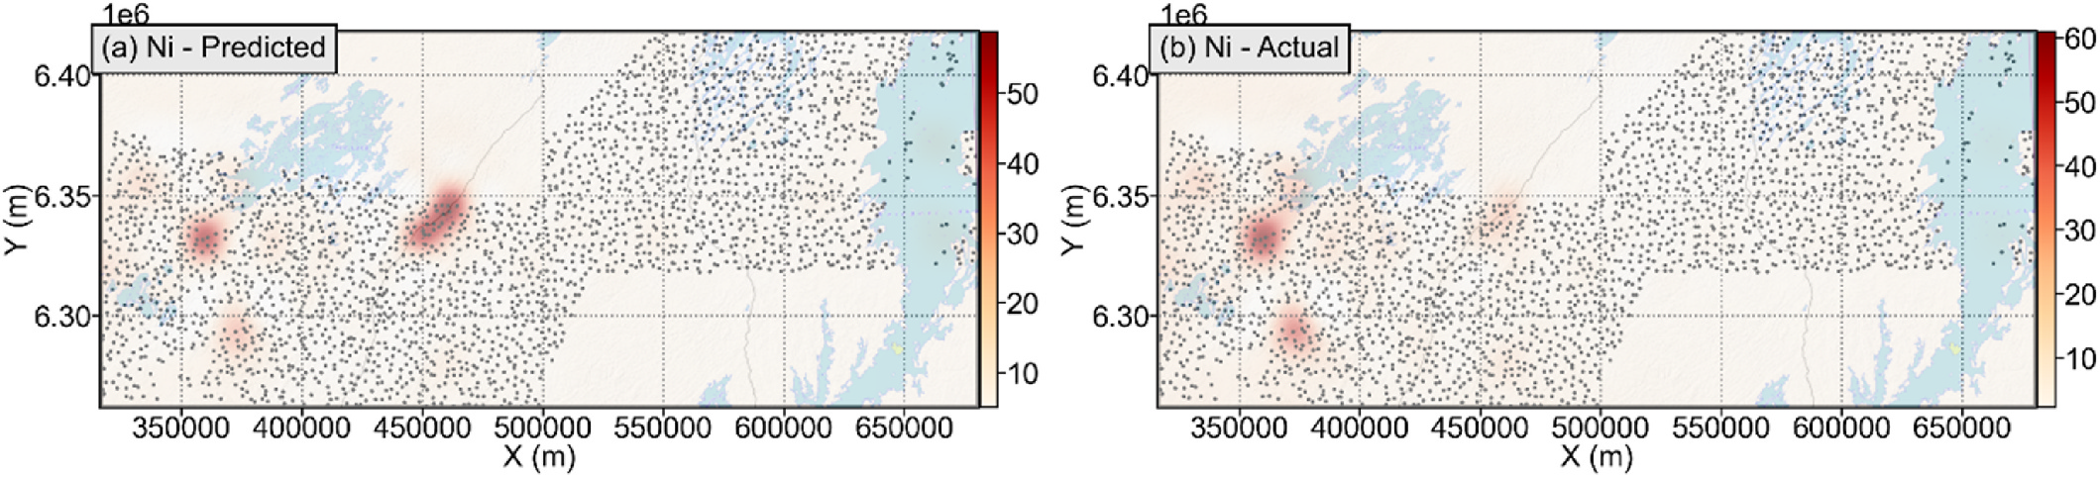

**Fig. 9.** Maps of the elemental concentration of Ni in the southwestern Churchill Province and Trans-Hudson Orogen region were created from (a) predicted con-centrations (ppm), and (b) actual concentrations (ppm).

91

*S.E. Zhang et al.*  *Artificial Intelligence in Geosciences 3 (2022) 86–100*

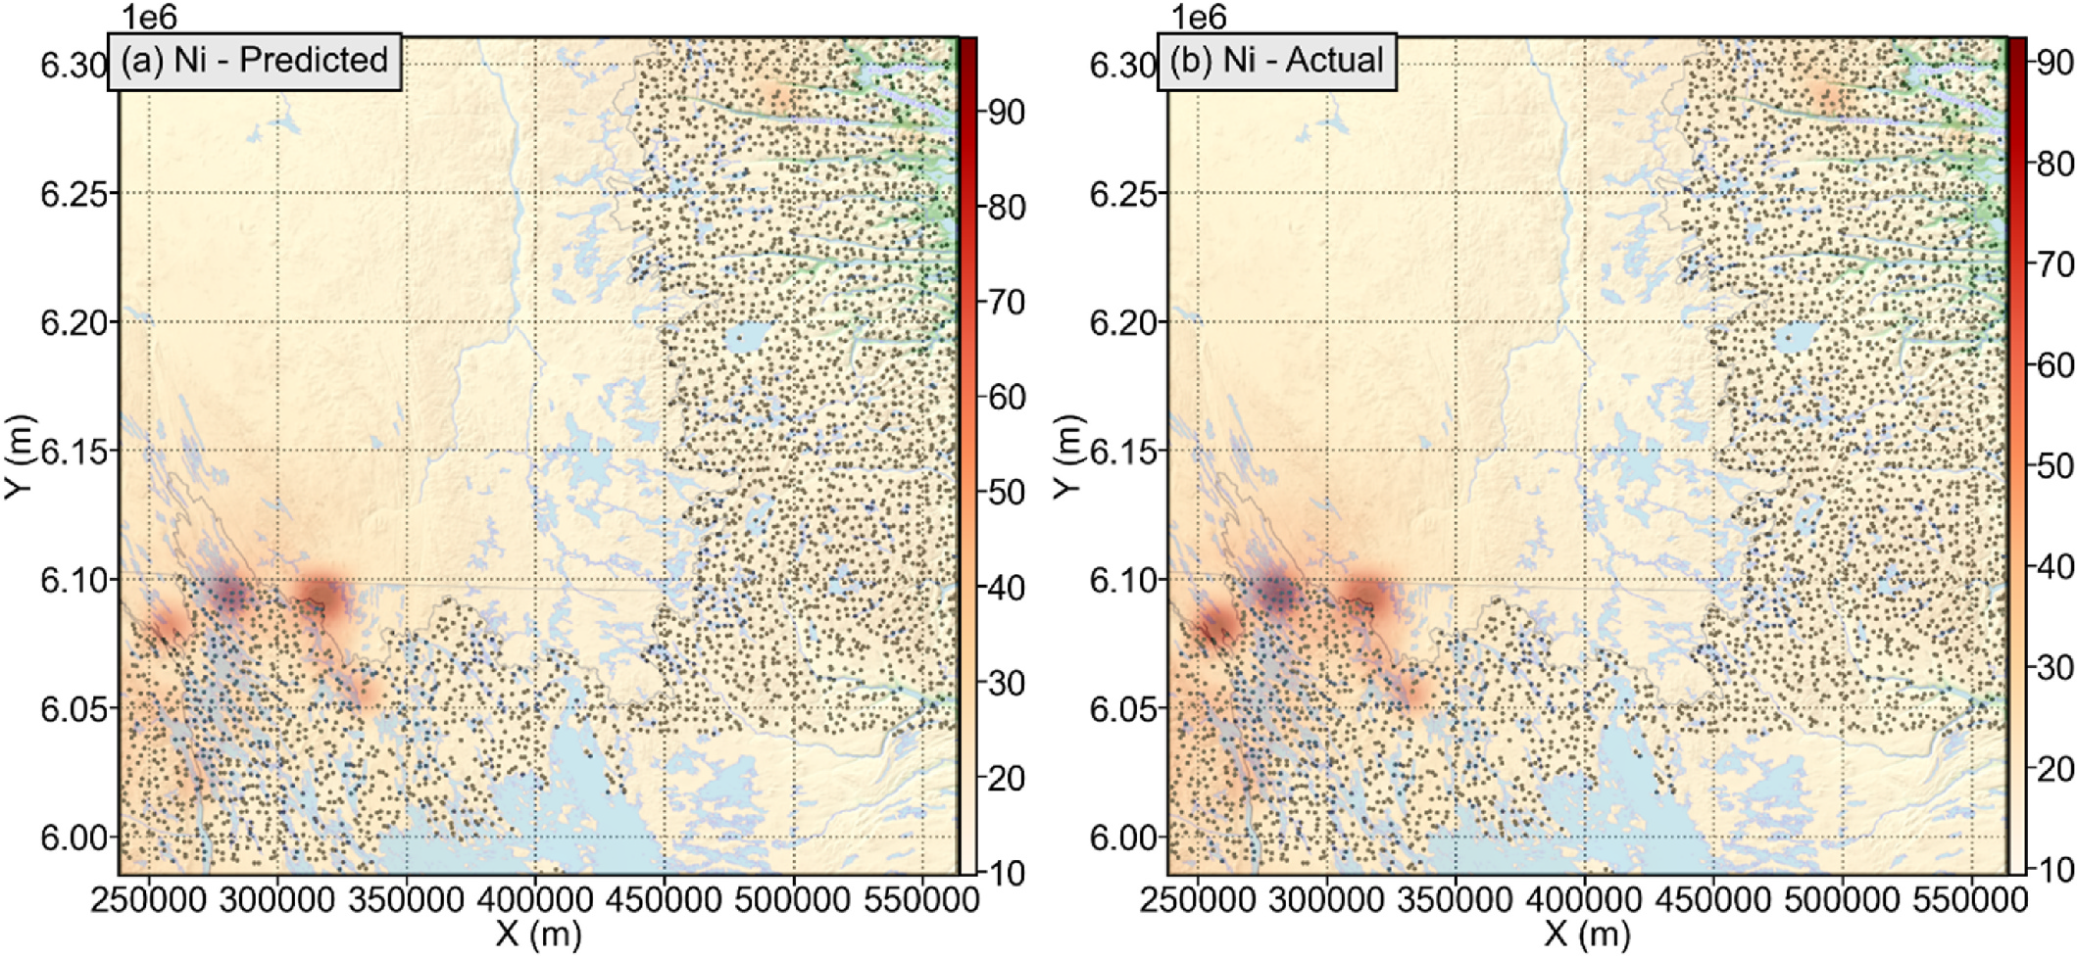

**Fig. 10.** Maps of the elemental concentration of Ni in the southeastern Churchill Province region were created from (a) predicted concentrations (ppm), and (b) actual concentrations (ppm).

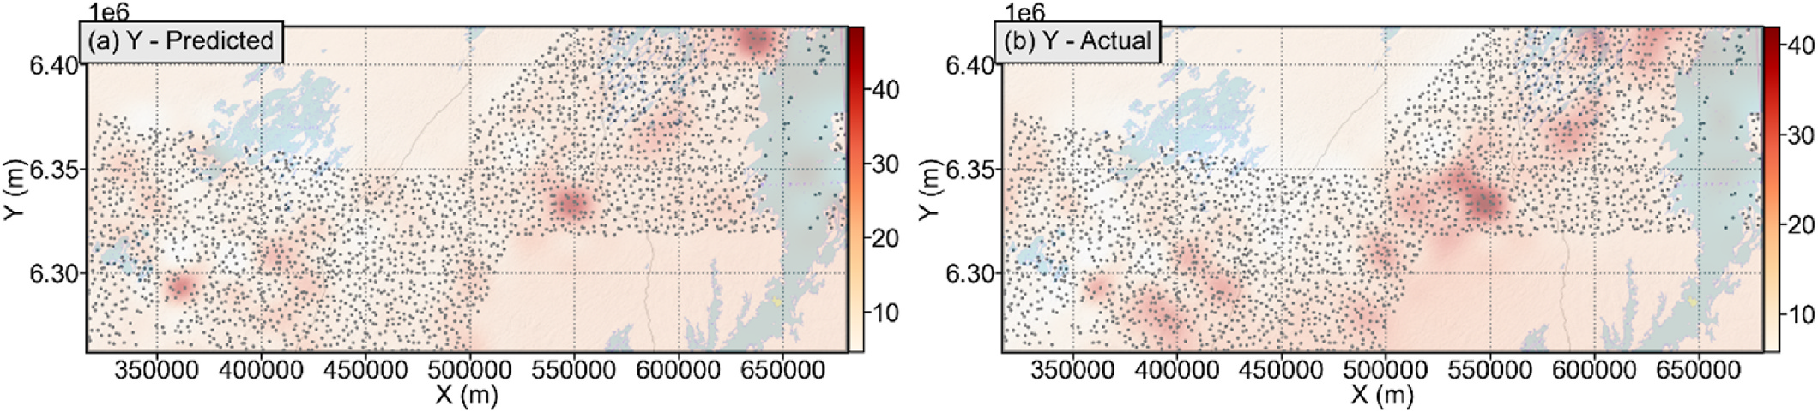

**Fig. 11.** Maps of the elemental concentration of Y in the southwestern Churchill Province and Trans-Hudson Orogen region were created from (a) predicted con-centrations (ppm), and (b) actual concentrations (ppm).

supracrustal rocks that were overlain by Paleoproterozoic supracrustal sequences (Card et al., 2007; Eglington et al., 2013). The province hosts several mineral deposits, notably in Au (Ithingo Lake deposit) and Fe (Nyberg Lake and Ithingo Lake deposits) (Saskatchewan Geological Survey, 2018). The Churchill Province is separated from the Superior Province to the southeast by the Paleoproterozoic Trans-Hudson Orogen (1.83–1.80 Ga; Corrigan et al., 2005). The Trans-Hudson Orogen itself is a collage of juvenile supracrustal belts, continental margin sediments and re-activated rocks from the Archean Superior and Churchill prov-inces (Hoffman, 1988; Corrigan et al., 2005; Yeo and Delaney, 2007). A number of base-metal (e.g., Cu–Zn, Pb–Zn, Fe, Cu–Ni-Platinum Group Elements [PGE], and REEs) occurrences are found in the Trans-Hudson Orogen (Yeo and Delaney, 2007; Saskatchewan Geological Survey, 2018). These basement rocks are overlain by the Paleoproterozoic to Mesoproterozoic Athabasca Group rocks (1.75–1.5 Ga; Cumming and Krstic, 1992; Rainbird et al., 2007; Ramaekers et al., 2007). The strati-graphic areas immediately above or below the unconformity between the basement and Athabasca Group rocks is well known for Athabasca unconformity-type uranium deposits (Jeanneret et al., 2016). Legacy geochemical data for this region similarly did not contain many ele-ments, such as the REEs.

92

*S.E. Zhang et al.*  *Artificial Intelligence in Geosciences 3 (2022) 86–100*

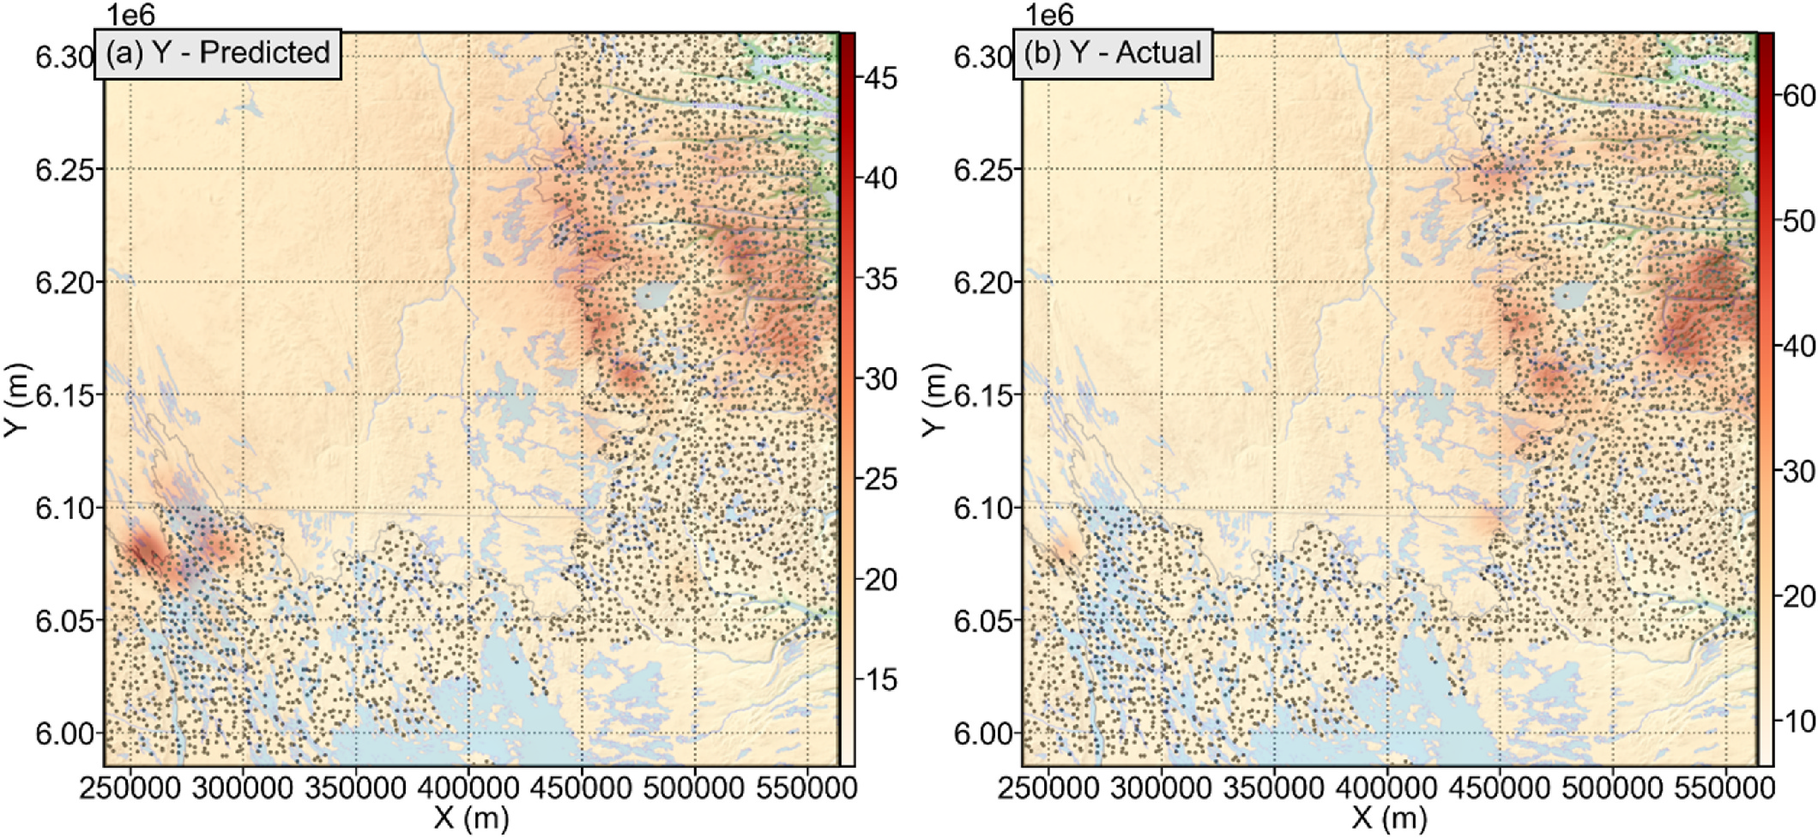

**Fig. 12.** Maps of the elemental concentration of Y in the southeastern Churchill Province region were created from (a) predicted concentrations (ppm), and (b) actual

concentrations (ppm).

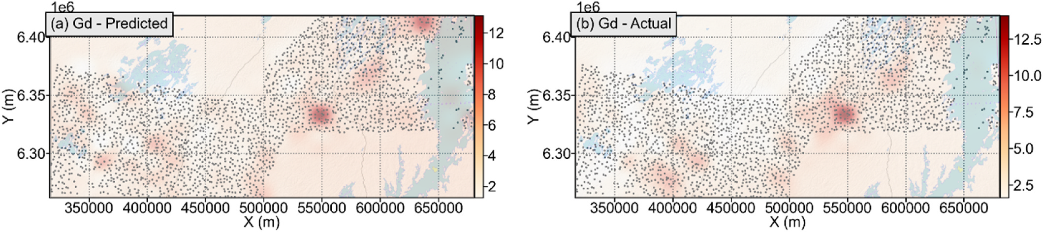

**Fig. 13.** Maps of the elemental concentration of Gd in the southwestern Churchill Province and Trans-Hudson Orogen region were created from (a) predicted

concentrations (ppm), and (b) actual concentrations (ppm).

reconstruction-based anomaly detection. The modified ML workflow uses elements that were analyzed in the legacy analyses (analyzed be-tween 1970 and 1980) as features and elements in the modern analyses as targets. Instead of systematically exploring all feasible machine learning algorithms, of which there are many (e.g., Zhang et al., 2021a, 2022), we choose to focus on the tuning and results of the random forest algorithm (Ho, 1995; Breiman, 1996a, b; Kotsiantis, 2014; Freund and Schapire, 1997; Sagi and Rokach, 2018). We base our selection on the fact that random forest was demonstrated to offer generally good and often the best performance for exactly this task relative to many other algorithms (Zhang et al., 2021a, 2022). For a full discussion around the random forest algorithm, and the other suitable algorithms that were explored, see Zhang et al. (2021a, 2022). For our task, some of the desirable properties of the random forest algorithm were summarized in Zhang et al. (2021a), which include a feature space that is devoid of native geometry and therefore makes no a-priori demands on the embedding space of the geochemical data. As such, it was empirically demonstrated that for the task of the prediction of trace elements, the random forest algorithm generally exhibited comparable performance across a large number of elements using both centered log ratio-transformed data and raw data, and in many cases, raw data pro-duced better results across a range of metrics (Zhang et al., 2021a, 2022). Therefore, we choose to use raw data for predictive modelling. Model construction follows the methodology as established by Zhang

93

*S.E. Zhang et al.*  *Artificial Intelligence in Geosciences 3 (2022) 86–100*

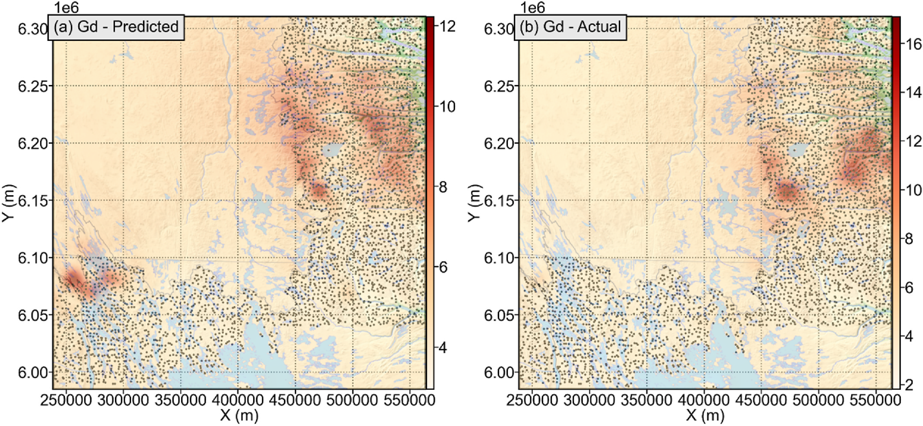

**Fig. 14.** Maps of the elemental concentration of Gd in the southeastern Churchill Province region were created from (a) predicted concentrations (ppm), and (b) actual concentrations (ppm).

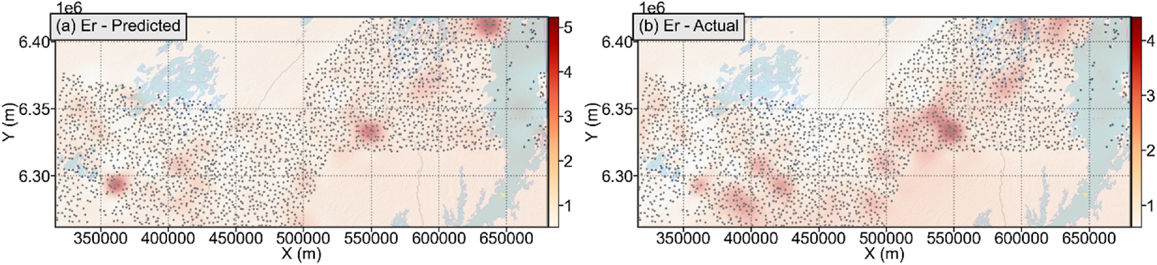

**Fig. 15.** Maps of the elemental concentration of Er in the southwestern Churchill Province and Trans-Hudson Orogen region were created from (a) predicted concentrations (ppm), and (b) actual concentrations (ppm).

spatial cross-validation using this method resembles how predictive modelling ahead of re-analyses would be operationalized.

**3. Results**

Model selection results demonstrate that the best-predicted elements are the elements that overlap between the legacy and modern geochemical analyses. In contrast, the other elements are predicted with a variable CoD (R2) depending on the element and the NTS zones (Fig. 4). Some elements are predicted poorly (CoD (R2) *<* 0.3; e.g., Sr and S). Some zones consistently predict worse across some elements, such as zone 013M and elements: Ho; Eu; Sm; Gd; Nd; Pr; Er; Dy; Tb; Y; Ce and Yb. This zone is known to contain some rare earth element- bearing geochemical anomalies associated with the Mistastin Batholith (McClenaghan et al., 2017, 2019 and references therein). As such, a reduction in prediction performance is expected, and indeed, data reconstruction performance was used to identify mineralization anom-alies (Zhang et al., 2021a, 2022). Results from testing using spatial cross-validation show that prediction of various elements at the NTS zone level is generally possible. In particular, predicted concentrations of the rare earth elements in zone 013M tend toward under-prediction (Fig. 5). This same behaviour was observed in Zhang et al. (2022).

The prediction performance observed through spatial cross-

94

*S.E. Zhang et al.*  *Artificial Intelligence in Geosciences 3 (2022) 86–100*

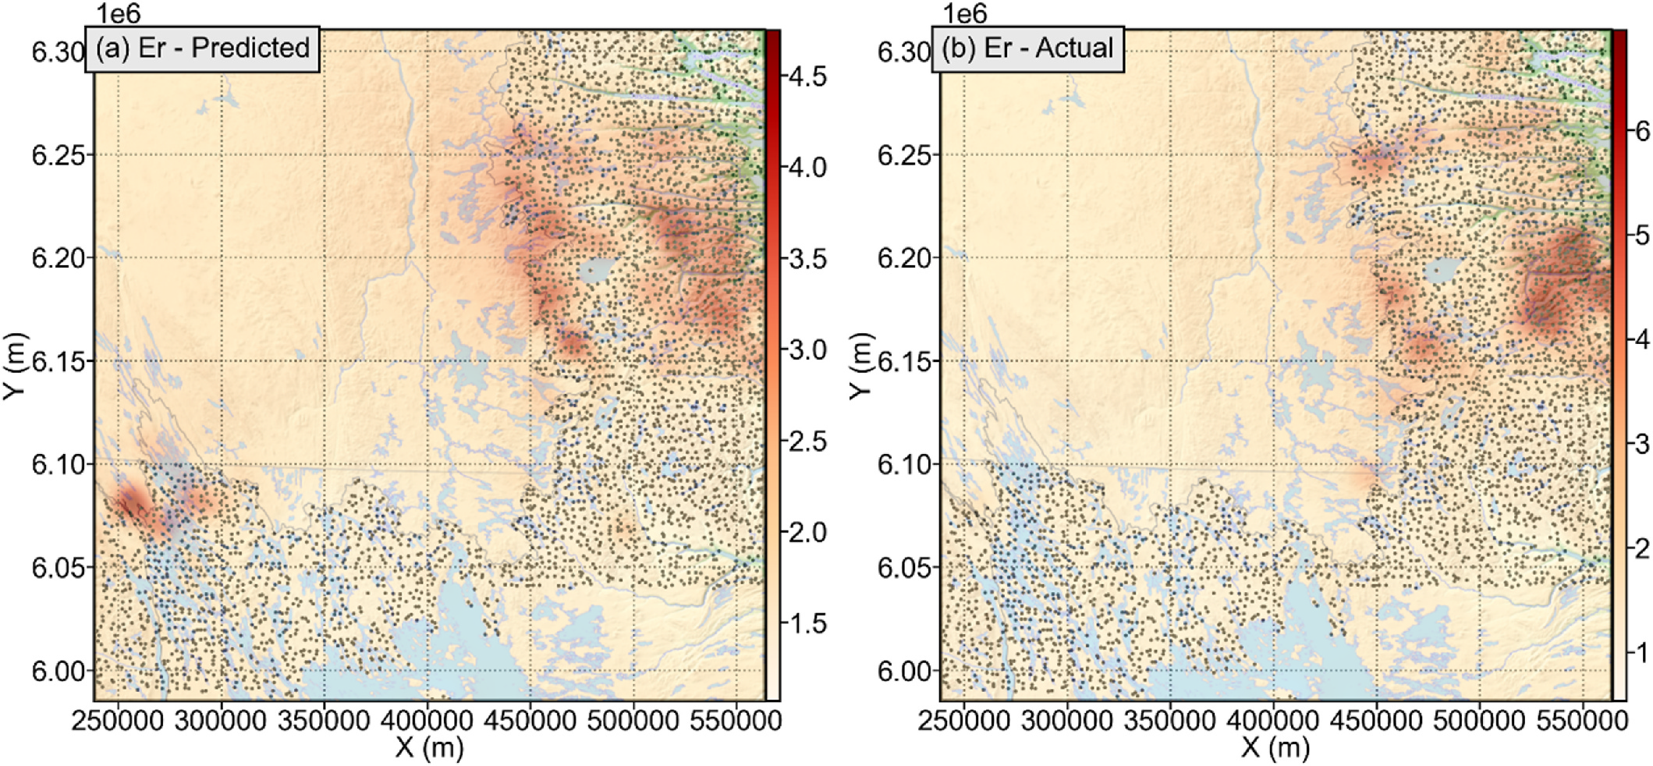

**Fig. 16.** Maps of the elemental concentration of Er in the southeastern Churchill Province region were created from (a) predicted concentrations (ppm), and (b) actual concentrations (ppm).

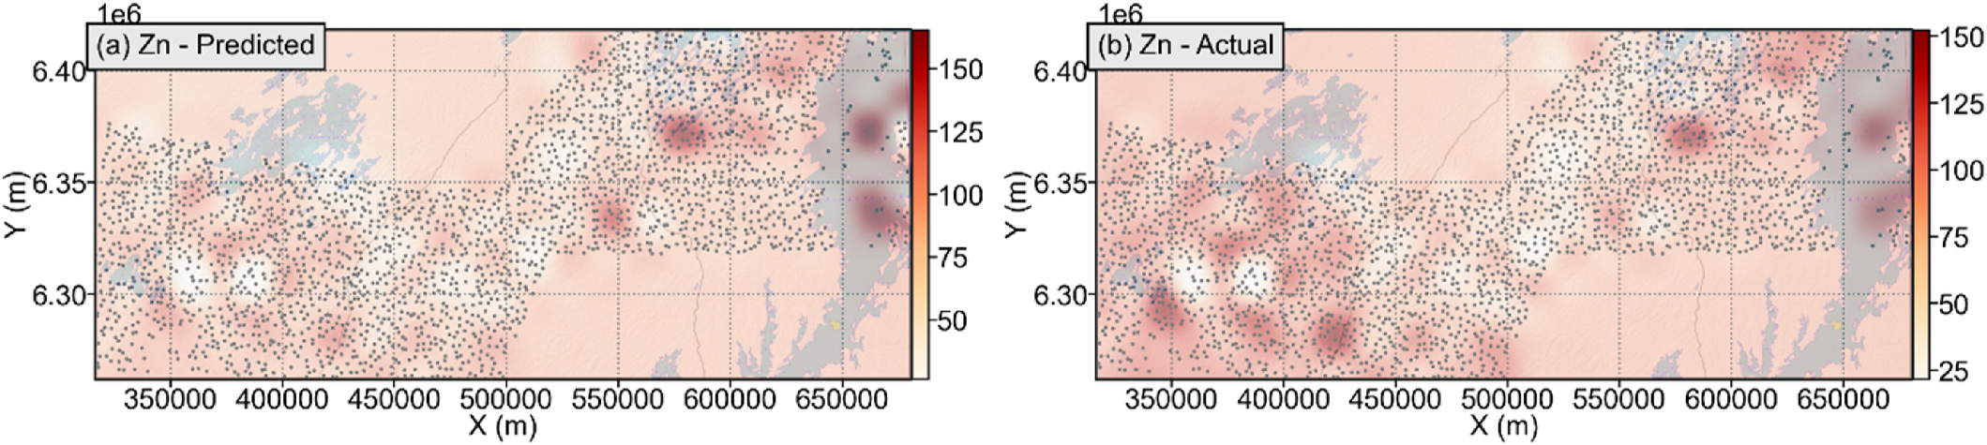

**Fig. 17.** Maps of the elemental concentration of Zn in the southwestern Churchill Province and Trans-Hudson Orogen region were created from (a) predicted concentrations (ppm), and (b) actual concentrations (ppm).

concentration maps (Figs. 9–20). The degree of spatial concordance is high for elements that were contained both in the legacy and modern datasets, such as Ni (Figs. 9 and 10). In fact, in the Strange Lake region (southeastern Churchill Province), the maps of the predicted and actual elemental concentrations are qualitatively indistinguishable (Figs. 9 and 10). In the southwestern Churchill Province and Trans-Hudson Orogen region, the Ni maps are qualitatively similar, but the prediction suggests a higher concentration in the central region of the map (Fig. 9). How-ever, predicting concentrations of elements that already exist in legacy data is less interesting than predicting currently unknown elemental concentrations. For rare earth elements, the degree of spatial concor-dance is generally good qualitatively because zones known to be enriched in some elements are predicted to be as such (Figs. 11–16). In particular, in the southeastern Churchill Province region, locations of known rare earth element-bearing anomalies such as the Strange Lake peralkaline complex and Misery Lake peralkaline syenite (Mistatin Batholith), as well as their dispersal trains are predicted to be enriched in those elements (Figs. 12, 14 and 16). For base metals, the degree of spatial concordance depends on the elemental overlap between the legacy and modern datasets and, in some cases, such as for Zn and Pb, the spatial concordance is quite good in the southeastern Churchill Province region (Figs. 18 and 20), but poorer in portions of the south-western Churchill Province and Trans-Hudson Orogen region (mainly the west half; Figs. 17 and 18).

95

*S.E. Zhang et al.*  *Artificial Intelligence in Geosciences 3 (2022) 86–100*

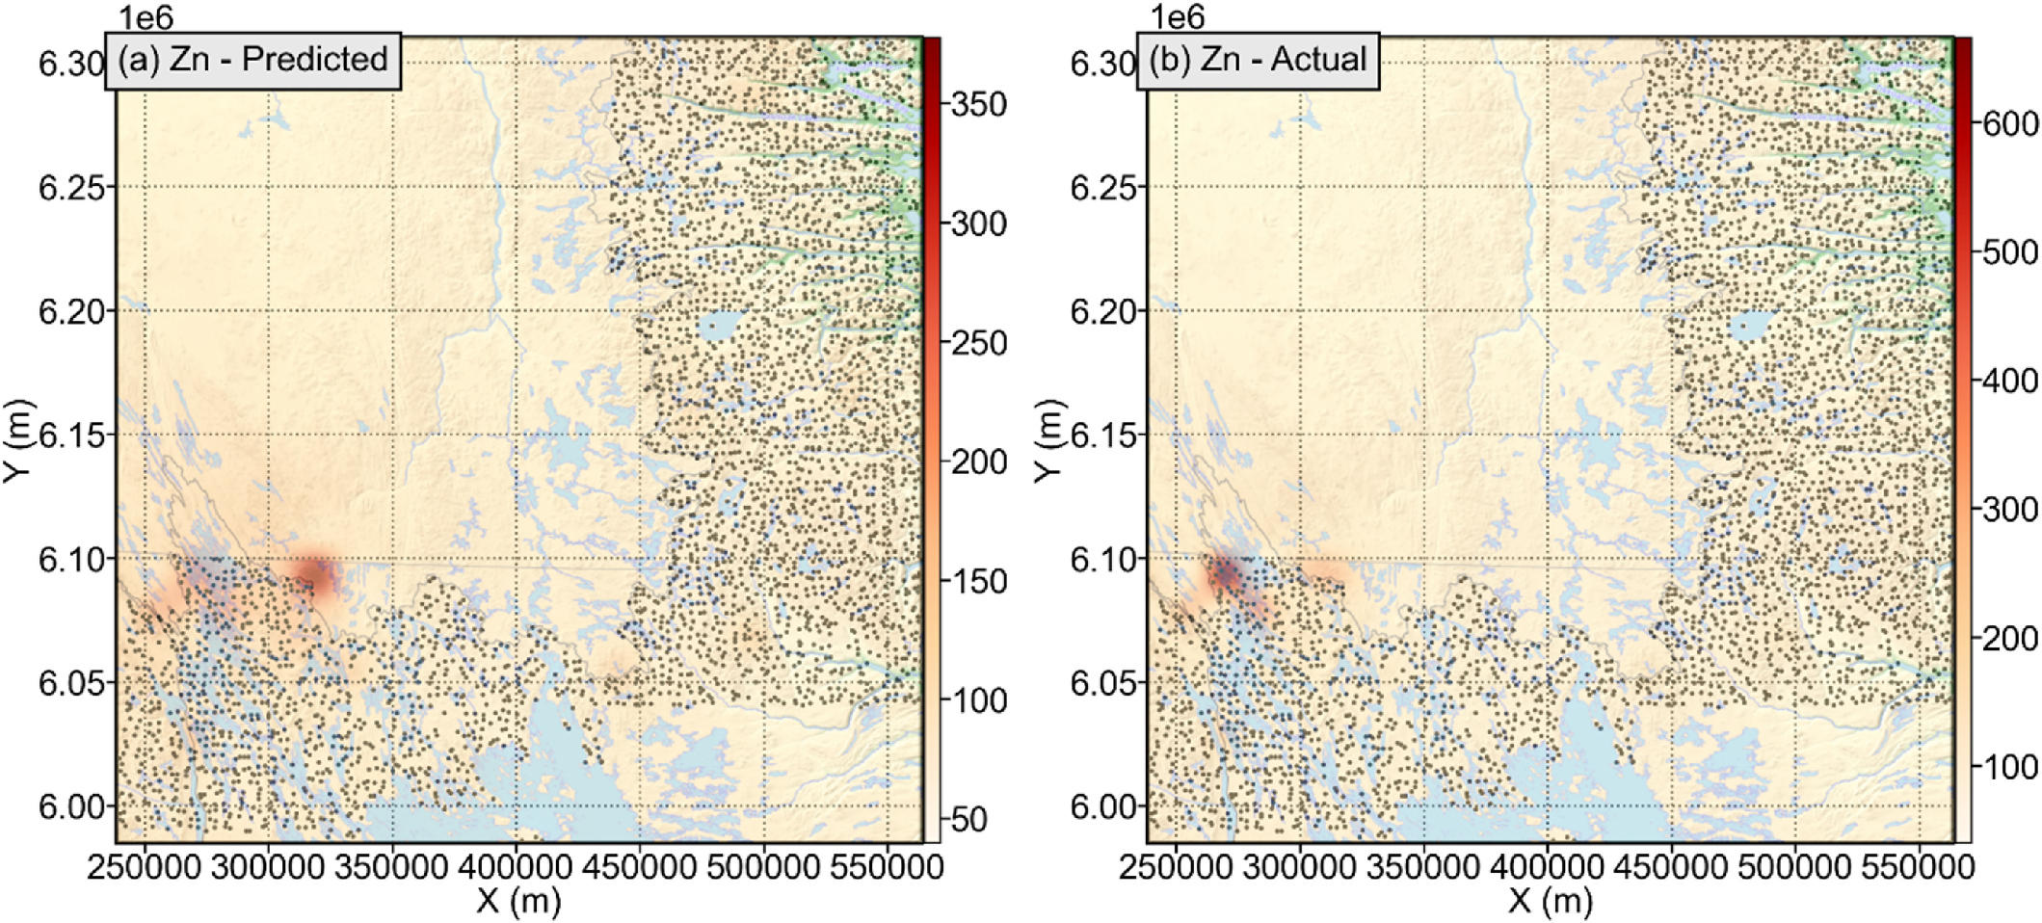

**Fig. 18.** Maps of the elemental concentration of Zn in the southeastern Churchill Province region were created from (a) predicted concentrations (ppm), and (b) actual concentrations (ppm).

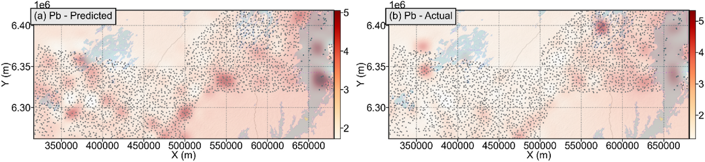

**Fig. 19.** Maps of the elemental concentration of Pb in the southwestern Churchill Province and Trans-Hudson Orogen region were created from (a) predicted concentrations (ppm), and (b) actual concentrations (ppm).

difference can be measured through the relative difference (image domain score minus raw predicted-data score, divided by the raw predicted-data score). The relative difference for: the CoD (R2) metric is about 42.21%; the MAPE metric is about −69.24%; and the MedAE metric is about −37.83%. This implies that the MAPE metric experi-enced the most improvement, followed by the CoD (R2) metric. Furthermore, for the MAPE and MedAE metrics and with the exception of Mn (Figs. 22 and 23), all elements systematically improved in the image domain relative to the same metrics evaluated on the raw pre-dicted data. This implies that predicted geochemical data is generally suitable for mapping.

**4. Discussion**

This study shows that it is possible to predict elemental concentra-tions for a range of elements in areas where legacy geochemical data exist, but the corresponding modern data is absent. Cross-validation can be used to anticipate prediction performance using a variety of metrics in the variable domain (Figs. 6–8). Elements to be predicted that are present in training data generally predict better in any given area than elements that are non-existent in training data (Figs. 6 and 7). This is no surprise, as information regarding such an element is more direct than the inference of presently unanalyzed elements. Therefore, predicted elemental concentration maps vary quantitatively in their accuracy

96

*S.E. Zhang et al.*  *Artificial Intelligence in Geosciences 3 (2022) 86–100*

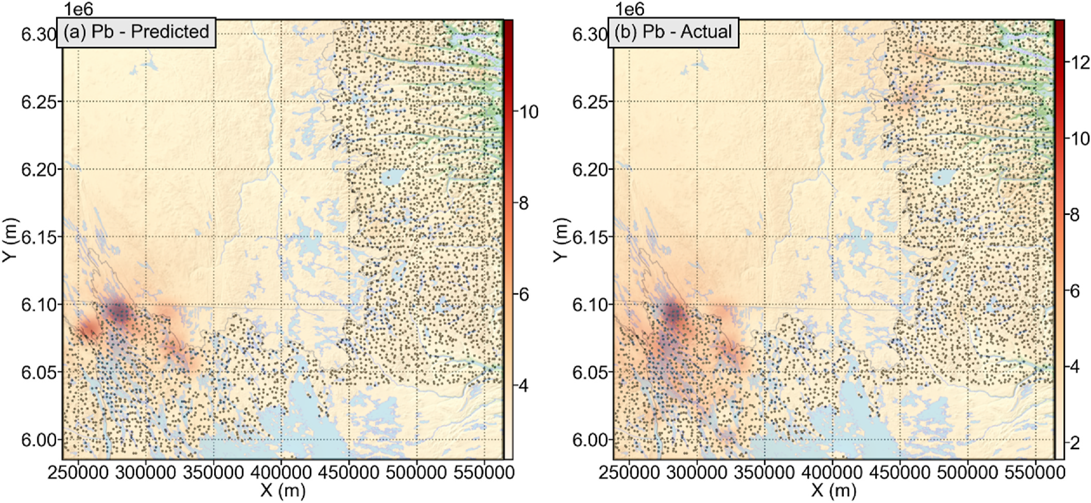

**Fig. 20.** Maps of the elemental concentration of Pb in the southeastern Churchill Province region were created from (a) predicted concentrations (ppm), and (b) actual concentrations (ppm).

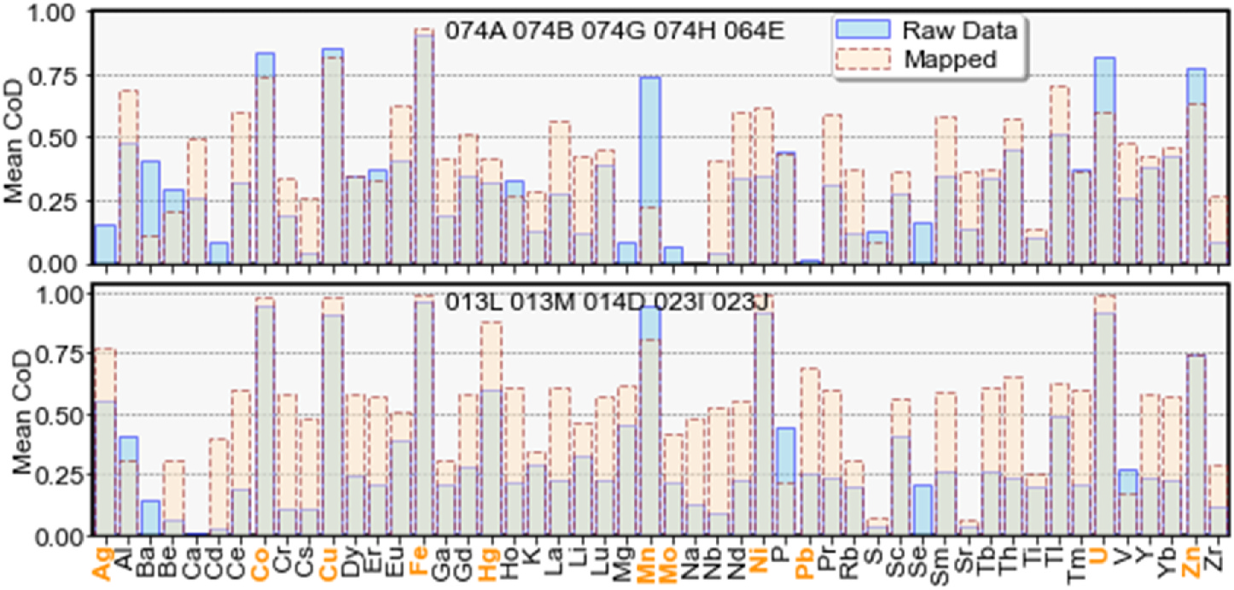

**Fig. 21.** Comparison of the CoD (R2) metric scores on a per-element basis between the raw predicted data and the mapped data. Elements that are found in all of the older datasets are shown in bold orange text (includes Pb, Mo, Ag, Hg, Mn, Ni, Zn, Co, Cu, Fe and U).

multivariate/multi-elemental concentration hotspots, for which some of the elements are very low in concentration. In any case, it is clear that because the predicted concentration maps generally bear a spatial resemblance to the actual concentration maps, such maps could be used to plan re-analyses or even additional sampling campaigns (Figs. 9–20). In addition, the predicted and actual hotspots are nearly always of the same order of magnitude, which is quantitatively supported by the MAPE metric scores (nearly always less than 100%, see Fig. 7), which implies that advanced targeting decisions could be made using predicted concentration maps, in lieu of waiting for the areas to be re-analyzed. This may be particularly important for time-sensitive elements, such as those belonging to the critical raw materials. In any case, multivariate concentration maps are likely to be generally more robust than single elemental maps, as stacking of several maps would attenuate spatial disagreements amongst the elements and enhance hotspots that are common across the elements. For much of the rare earth elements, their geochemical behaviour is comparable. Therefore, grouping them together to generate final multivariate elemental maps is a good use of the prediction results. This will be useful for advanced exploration of

97

*S.E. Zhang et al.*  *Artificial Intelligence in Geosciences 3 (2022) 86–100*

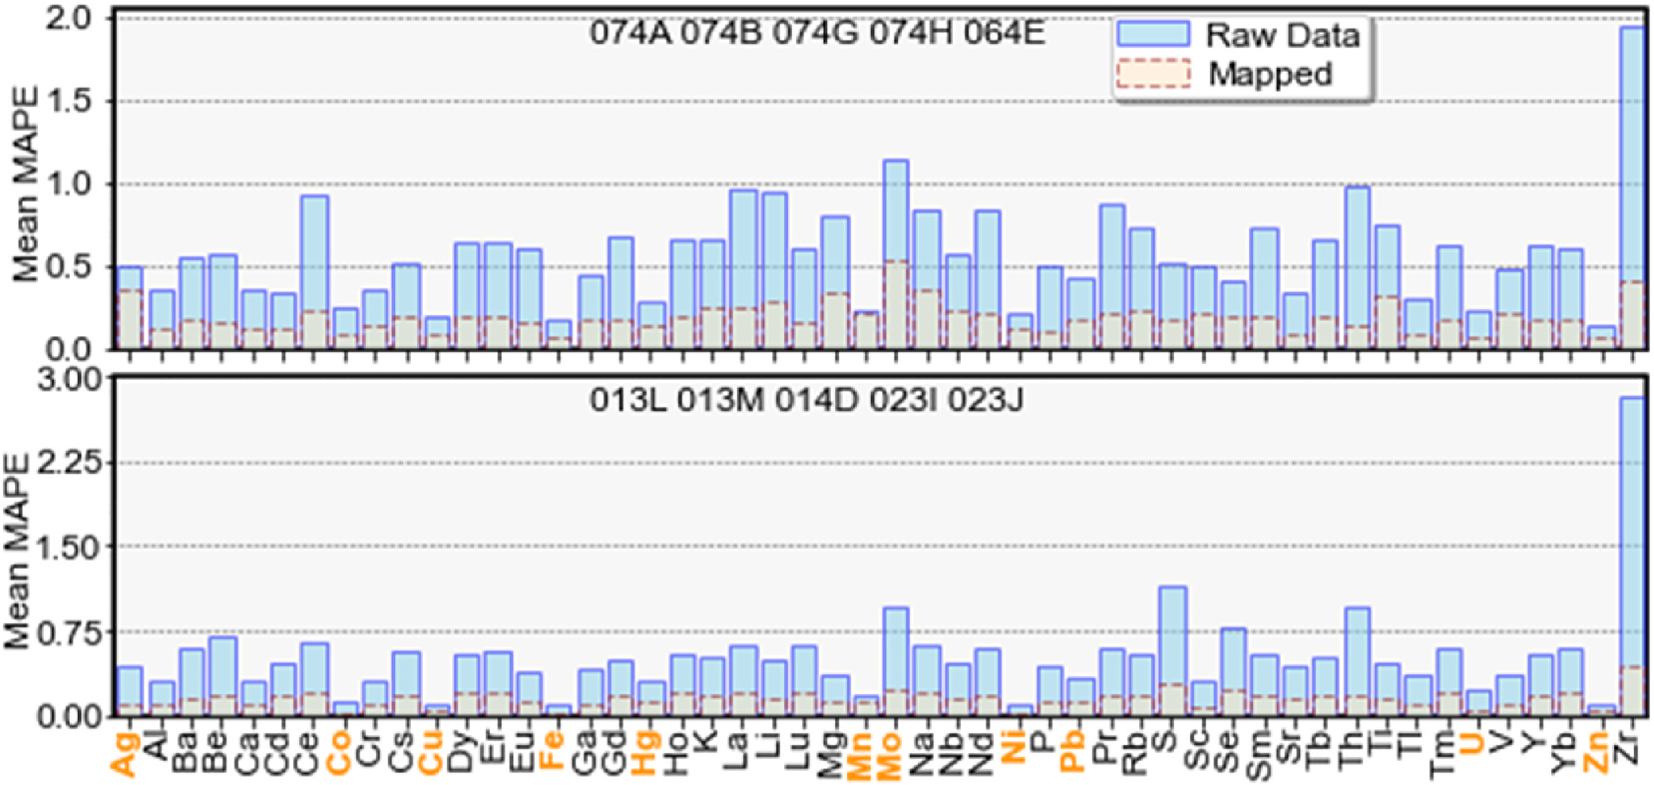

**Fig. 22.** Comparison of the MAPE metric scores on a per-element basis between the raw predicted data and the mapped data. Elements that are found in all of the older datasets are shown in bold orange text (includes Pb, Mo, Ag, Hg, Mn, Ni, Zn, Co, Cu, Fe and U).

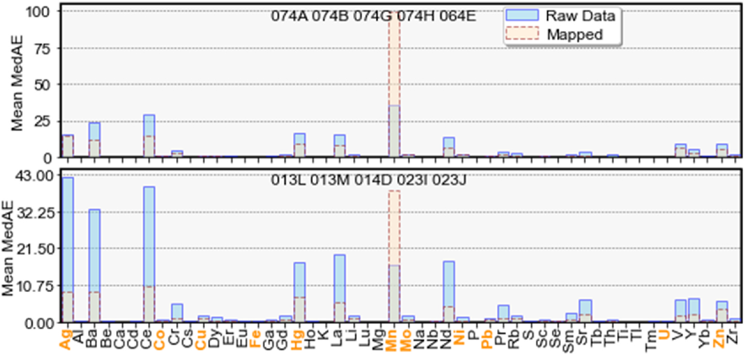

**Fig. 23.** Comparison of the MedAE metric scores on a per-element basis between the raw predicted data and the mapped data. Elements that are found in all of the older datasets are shown in bold orange text (includes Pb, Mo, Ag, Hg, Mn, Ni, Zn, Co, Cu, Fe and U).

words, prediction and training using contrasting compositions of sam-ples, e.g., training on sediment samples derived from parental igneous rocks and testing on sediment samples derived from conglomerates, is unlikely to produce optimal performance. There are several classes of factors that can contribute to significant losses in prediction perfor-mance in this manner: (1) scientific factors; and (2) data factors. Sci-entific factors include the abundance of relationships (e.g., types of minerals in samples) between the target elements and the features. For example, an element is found in spatially disparate stoichiometries in samples that vary at a spatial scale roughly the size of the NTS zones (a type of mineral spatial non-stationarity through e.g., the distribution of parent lithologies). In this case, in the worst case, there are unique re-lationships between the targets and features within each zone and generalization to unknown zones is critically dependent on having suf-ficient types of relationships captured in the training data. Data factors include under-sampling of key relationships for some elements and class imbalance issues. To some extent, all of these issues can be reduced in their impacts through increasing the diversity of the training data through the availability of more re-analyses. Sourcing more data through other sources external to GEM, such as provincial, academic and private industry data may also be a means to augment the diversity of the training data. However, discrepancies between sample collection, preparation and analysis methods should ideally be taken into account

98

*S.E. Zhang et al.*  *Artificial Intelligence in Geosciences 3 (2022) 86–100*

nature of the analyses facilitates the comprehension of sampling and analytical methodologies. This should be as applicable for GEM data as it is for similar data, wherever conditions are met (e.g., fusable legacy and modern datasets). The availability of common standards enables data levelling in the future, where its effects are intolerable. Where the pre-dicted elemental concentration maps are used qualitatively (e.g., to plan re-analysis or sampling campaigns) instead of quantitatively (e.g., to substitute for re-analyses in an exploration campaign or to be used with scientifically reductive methods downstream), quantitative matching of data levels may be unnecessary depending on the application context and the extent of its impacts.

The ability to generate a-priori knowledge regarding previously unknown elemental concentrations in new areas is the most significant finding of this study. We demonstrated that where previous analyses exist in the form of legacy data, it is possible to anticipate the elemental concentrations of many unanalyzed elements with sufficient accuracy in the spatial domain to be widely applicable. Where exploration programs were sufficiently regimental to have had standardized sampling and analysis methodology, and some implementation of a data repository that facilitates the use of particularly legacy data, the legacy data and modern data are a key program asset that enables predictive oper-ationalization. Our finding implies that re-analysis campaigns and exploration for time-sensitive elements (e.g., critical raw materials) could become prioritized based on anticipated elemental concentrations and current exploration priorities. For example, in the search for rare earth elements, it is possible to sequentially target areas (both for further downstream prospectivity mapping or for detailed field study and sampling) based on a rank-order of their anticipated rare earth elemental concentrations. This effectively reduces the time to discover new mineral deposits by reshaping the exploration pipeline to become more predictive in a target- and data-driven manner. In this case, geological knowledge of target areas is an asset but not a requirement, as the decision to target is data-driven. However, geoscientific knowledge is indispensable for interpreting and verifying relevant geochemical hotspots in predicted elemental maps. In some situations, aside from exploration prioritization, advanced geochemical data through predic-tive modelling may be the only form of modern geochemical data, and such data is better than legacy data alone. This would be the case in circumstances satisfying one or more of: (1) the time to modernize data in an area of interest is too long for a practical purpose; (2) there is insufficient material remaining for another re-analysis and/or re- sampling is no longer possible (e.g., due to changes in land use; geopolitics; environmental, social and governance factors); (3) there is no additional resource to execute another re-analysis campaign; (4) probable rather than known concentrations are adequate for down-stream uses of data; and (5) re-analysis is contingent on more geochemical information becoming available in target areas.

**5. Conclusion**

Predictive data generation can play a pivotal role in the moderni-zation of exploration programs by providing probable data in advance of actual data. We have demonstrated that by using legacy data, modern data and leveraging the extensive standardization of data and its gen-eration processes within existing geochemical survey programs, it is possible to generate probable and often quantitatively or qualitatively reliable modern data. In this manner, our proposed method not only extracts additional value from otherwise outdated (legacy) data, but also serves to assist with both upstream data generation and downstream data usage. For exploration geochemistry, the rate-limiting step is data generation. This context is mismatched with the data-hungry and automation capacity of data-driven techniques, which are becoming key downstream consumers of exploration data and can quickly exhaust existing data. In this case, our method serves to enable data users, such as prospectivity mappers, with valuable and timely information that otherwise may be completely absent or may be untimely. This would

99

*S.E. Zhang et al.*  *Artificial Intelligence in Geosciences 3 (2022) 86–100*

[David, J., Simard, M., Bandyayera, D., Goutier, J., Hammouche, H., Pilote, P., Leclerc, F.,](http://refhub.elsevier.com/S2666-5441(22)00029-6/sref12) [Dion, C., 2012. Datations U-Pb effectu´ees dans les provinces du Sup´erieur et de](http://refhub.elsevier.com/S2666-5441(22)00029-6/sref12) [Churchill en 2010-2011. Minist`ere des Ressources Naturelles. Qu´ebec, p. 33. RP](http://refhub.elsevier.com/S2666-5441(22)00029-6/sref12) [2012-01.](http://refhub.elsevier.com/S2666-5441(22)00029-6/sref12)

de M[yttenae](http://refhub.elsevier.com/S2666-5441(22)00029-6/sref12)re, A., Golden, B., Le Grand, B., Rossi, F., 2016. Mean absolute percentage error for regression models. Neurocomputing 192, 38–48. [https://doi.org/10.1016/](https://doi.org/10.1016/j.neucom.2015.12.114) [j.neucom.2015.12.114](https://doi.org/10.1016/j.neucom.2015.12.114).

Egli[ngton, B.M., Pehrsson,](https://doi.org/10.1016/j.neucom.2015.12.114) S.J., Ansdell, K.M., Lescuyer, J.L., Quirt, D., Milesi, J.P., Brown, P., 2013. A domain-based digital summary of the evolution of the Palaeoproterozoic of North America and Greenland and associated unconformity- related uranium mineralization. Precambrian Res. 232, 4–26. [https://doi.org/](https://doi.org/10.1016/j.precamres.2013.01.021) [10.1016/j.precamres.2013.01.021](https://doi.org/10.1016/j.precamres.2013.01.021).

Freu[nd, Y., Schapire, R.E., 1997. A de](https://doi.org/10.1016/j.precamres.2013.01.021)cision-theoretic generalization of on-line learning and an application to boosting. J. Comput. Syst. Sci. 55 (1), 119–139. [https://doi.](https://doi.org/10.1006/jcss.1997.1504) [org/10.1006/jcss.1997.1504](https://doi.org/10.1006/jcss.1997.1504).

[Fris](http://refhub.elsevier.com/S2666-5441(22)00029-6/sref16)[ke, P.W.B., Hornbrook, E.H.W](https://doi.org/10.1006/jcss.1997.1504)[., 1991. Canada’s national geochemical reconnaissance](http://refhub.elsevier.com/S2666-5441(22)00029-6/sref16) [programme. In: Transactions of the Institution of Mining and Metallurgy, Section B.](http://refhub.elsevier.com/S2666-5441(22)00029-6/sref16) [Applied Earth Science, vol. 100, pp. B47–B56.](http://refhub.elsevier.com/S2666-5441(22)00029-6/sref16)

GEM[-GeoNorth, 2022. Geoscientific Research in](http://refhub.elsevier.com/S2666-5441(22)00029-6/sref16) Canada’s North: GEM-GeoNorth from.

[https://www.nrcan.gc.ca/earth-sciences/resources/federal-programs/geomapping](https://www.nrcan.gc.ca/earth-sciences/resources/federal-programs/geomapping-energy-minerals/18215) [-energy-minerals/18215. (Accessed 9 May 2022).](https://www.nrcan.gc.ca/earth-sciences/resources/federal-programs/geomapping-energy-minerals/18215)

Geo[logical Survey of Canada](https://www.nrcan.gc.ca/earth-sciences/resources/federal-programs/geomapping-energy-minerals/18215), 2022. Geological survey of Canada: report on results and delivery 2020-2021. Natural Resources Canada 137. [https://doi.org/10.4095/](https://doi.org/10.4095/328919) [328919](https://doi.org/10.4095/328919).

[Gow](http://refhub.elsevier.com/S2666-5441(22)00029-6/sref19)[ans, R.](https://doi.org/10.4095/328919)[M., Lewis, W.J., Shoemaker, S., Spooner, J., Zalnieriunas, R.V., 2014. NI-43-](http://refhub.elsevier.com/S2666-5441(22)00029-6/sref19) [101 Technical Report on the Preliminary Economic Assessment (PEA) for the Strange](http://refhub.elsevier.com/S2666-5441(22)00029-6/sref19) [Lake Property, Quebec, Canada. Micron International Limited for Quest Rare](http://refhub.elsevier.com/S2666-5441(22)00029-6/sref19) [Minerals Ltd., p. 258](http://refhub.elsevier.com/S2666-5441(22)00029-6/sref19)   
[Ham](http://refhub.elsevier.com/S2666-5441(22)00029-6/sref20)[mouche, H., Legouix](http://refhub.elsevier.com/S2666-5441(22)00029-6/sref19)[, C., Goutier, J., Dion, C., 2012. G´eologie de la r´egion du lac](http://refhub.elsevier.com/S2666-5441(22)00029-6/sref20) [Zeni. Minist`ere des Ressources Naturelles Qu´ebec, p. 35. RG 2012-02.](http://refhub.elsevier.com/S2666-5441(22)00029-6/sref20)

Ho, [T.K., 1995. Random decision forests. In: Proceedings of the 3rd Inter](http://refhub.elsevier.com/S2666-5441(22)00029-6/sref20)national Conference on Document Analysis and Recognition. Montr´eal, pp. 278–282. [https://](https://doi.org/10.1109/ICDAR.1995.598994) [doi.org/10.1109/ICDAR.1995.598994](https://doi.org/10.1109/ICDAR.1995.598994).

Hoff[man, P.F., 1988. United plates of Am](https://doi.org/10.1109/ICDAR.1995.598994)erica, the birth of a craton: early Proterozoic assembly and growth of Laurentia. Annu. Rev. Earth Planet. Sci. Lett. 16, 543–603. <https://doi.org/10.1146/annurev.ea.16.050188.002551>.

Jam[es, D.T., Connelly, J.N., Wasteneys, H.A., Kilfoil, G.J., 1](https://doi.org/10.1146/annurev.ea.16.050188.002551)996. Paleoproterozoic lithotectonic divisions of the southeastern Churchill Province, western Labrador. Can. J. Earth Sci. 33, 216–230. <https://doi.org/10.1139/e96-019>.

James, D.T., Dunning, G.R., 2000. U[–Pb geochronological constraints](https://doi.org/10.1139/e96-019) for   
Paleoproterozoic evolution of the Core zone, southeastern Churchill province, northeastern Laurentia. Precambrian Res. 103, 31–54. [https://doi.org/10.1016/](https://doi.org/10.1016/S0301-9268(00)00074-7) [S0301-9268(00)00074-7](https://doi.org/10.1016/S0301-9268(00)00074-7).

Jean[neret, P., Gondlaves, P.,](https://doi.org/10.1016/S0301-9268(00)00074-7) Durand, C., Trap, P., Marquer, D., Quirt, D., Ledru, P., 2016.

Tectono-metamorphic evolution of the pre-athabasca basement within the wollaston-mudjatik transition zone, saskatchewan. Can. J. Earth Sci. 53, 231–259. <https://doi.org/10.1139/cjes-2015-0136>.

[Kotsiantis, S.B., 2014. Integrating global and local application of naive bayes classifier](http://refhub.elsevier.com/S2666-5441(22)00029-6/sref26). [Int. Arab J. Inf. Technol. 11 (3), 300–307.](http://refhub.elsevier.com/S2666-5441(22)00029-6/sref26)

Kirk[wood, C., Cave, M., Beamish, D., Grebby,](http://refhub.elsevier.com/S2666-5441(22)00029-6/sref26) S., Ferreira, A., 2016. A machine learning approach to geochemical mapping. J. Geochem. Explor. 167, 49–61. [https://doi.](https://doi.org/10.1016/j.gexplo.2016.05.003) [org/10.1016/j.gexplo.2016.05.003](https://doi.org/10.1016/j.gexplo.2016.05.003).

Lebe[l, D., 2020. Geological Survey of C](https://doi.org/10.1016/j.gexplo.2016.05.003)anada 8.0: mapping the journey towards predictive geoscience. In: Hill, P.R., Lebel, D., Hitzman, M., Smelror, M., Thorleifson, H. (Eds.), The Changing Role of Geological Surveys. The Geological Society, London, Special Publication, pp. 49–69. [https://doi.org/10.1144/SP499-](https://doi.org/10.1144/SP499-2019-79) [2019-79](https://doi.org/10.1144/SP499-2019-79).

McC[lenagha](https://doi.org/10.1144/SP499-2019-79)n, M.B., Paulen, R.C., Kjarsgaard, I.M., 2019. Rare metal indicator minerals in bedrock and till at the Strange Lake peralkaline complex, Quebec and Labrador, Canada. Can. J. Earth Sci. 56 (8), 857–869. [https://doi.org/10.1139/cjes-2018-](https://doi.org/10.1139/cjes-2018-0299) [0299](https://doi.org/10.1139/cjes-2018-0299).

100